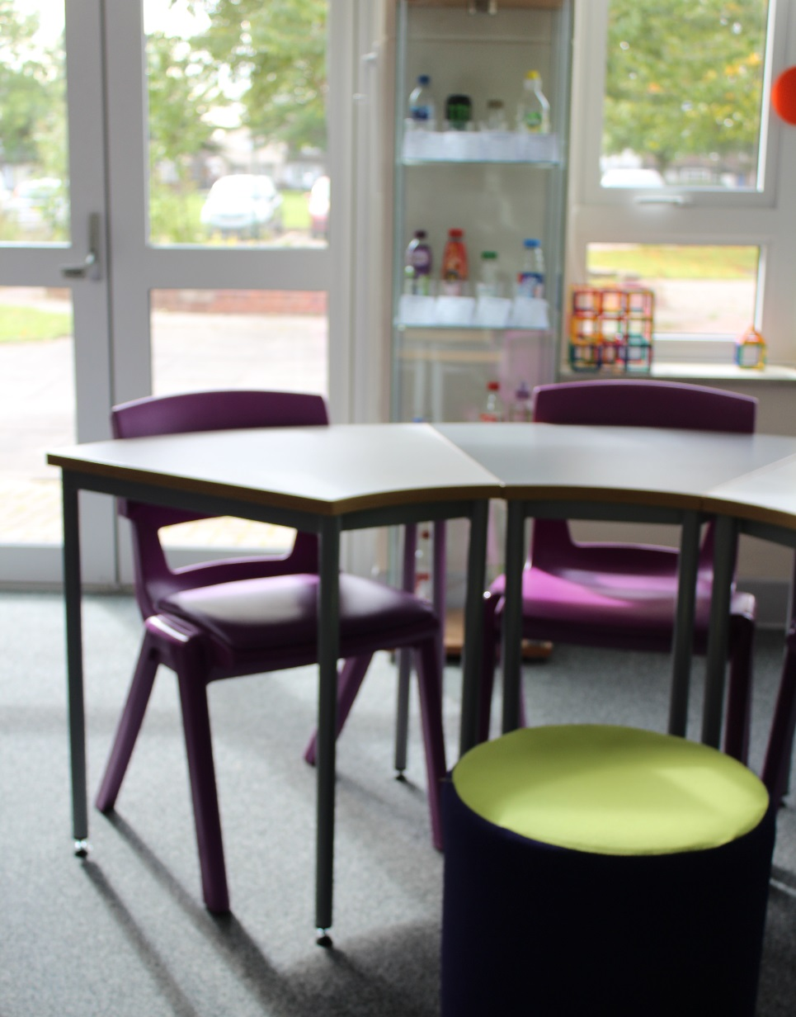
Leicester Children’s Hospital School


Training & Support
offer for schools /
external support

Programme
2022/23

Training & Support

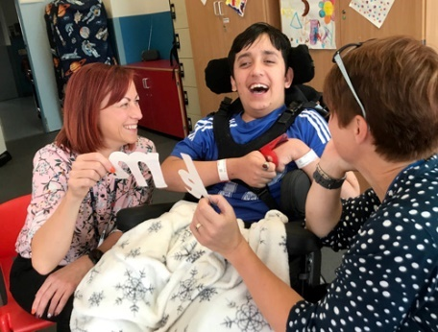
At Leicester Children’s Hospital School, we are committed to supporting schools and other partners through a regular CPD programme and a bespoke training offer which can be delivered in your setting to small groups or whole staff teams. We are a member of the National Association for Hospital Education and work in collaboration with a number of teaching schools across the region.

Our offer includes the following:
- Youth Mental Health First Aid qualifications (MHFA accredited)
- Regular CPD twilight programme of events at our school or online
- Bespoke ‘in-house’ training for your school or provision
- SLE and LLE deployment in schools
- Development of resources and policies to support children with medical needs
- Art therapy sessions for young people
- School audits to evaluate medical needs provision and offer advice
- Opportunity to visit our school

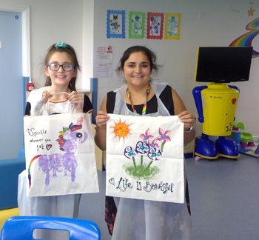

“I wanted to say thank you for your support. It has encouraged me to consider tweaking the presentation of our holistic and academic data slightly so that it is easier to identify progress and those ‘stuck’ pupils.”

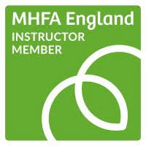
Youth Mental Health First Aid

What is Mental Health First Aid?
Mental Health First Aid (MHFA) is an internationally recognised training course which teaches people how to spot the signs and symptoms of mental ill health and provide help on a first aid basis.

MHFA offers a range of courses tailored for people who teach, work, live with and care for young people aged 8 to 18. The courses can be attended by anyone from age 16 upwards. Every MHFA England course is delivered by a quality assured Instructor Member.

What will I learn?
The course provides a more in depth understanding of specific mental health issues and is delivered in four manageable chunks:
- What is mental health?
- Depression and anxiety
- Suicide and psychosis
- Self-harm and eating disorders

The course focuses on the issues faced by young people today, such as cyber bullying and substance misuse, and teaches how to promote protective factors and good parenting. The course will increase awareness around young people’s mental health. Allowing you to develop practical skills to identify a range of mental health issues and support a young person to get the help they need. Completing the 2-day course qualifies you as a Youth Mental Health First Aider.

Facilitator: Lorraine Biddle – MHFA Accredited Instructor / Head of School, The Beacon CAMHS unit

Dates: | September 8th & 9th, November 3rd & 4th 2023, February 16th & 17th, May 11th & 12th 2023
Time: | 8.45am arrival for a 9.00am start – 5.00pm finish
Venues: | Eyres Monsell Club for Young People (September)  Soar Valley College Training Centre, Gleneagles Avenue, Leicester LE4 7GY  (November, February, and May)
Cost: | £250 per person including resources and refreshments
Please click on our Eventbrite link below for available dates and to make a booking:
The Children's Hospital School Events | Eventbrite
We are also able to deliver this 2-day course in your school or trust. For further details and to discuss costs, please email:
training@childrenshospitalschool.leicester.sch.uk

Evaluation Feedback from a recent 2-day Youth MHFA Course

“It was an excellent course with just the right mix of delivery, activity and time for discussion.”

“I feel better prepared now, to deal with mental health issues that may arise with the young people I work with.”

“The activities we did on the day were so well sequenced and really did make you think/reflect/learn.”

“The course materials are so useful and it’s lovely to have reference materials and support to go away with.”

“The knowledge and understanding I have gained over these two days really is so valuable.”

“This has honestly been the best CPD that I have done in years.”

“The whole course has been so well thought through.”

“I cannot promote this course enough.”

“Very informative course and I loved it all!”

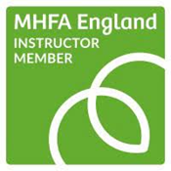

School CPD Programme 
We organise regular training sessions online or in person. Details of our upcoming courses are below, and bookings can be made by emailing us or by visiting our Eventbrite page.

Date | Event | Venue / cost | Facilitator(s)
Thursday  22nd September 2022  (2.30 – 3.30pm) | Supporting children with medical needs and Individual Health Care Plans  - To ensure that schools are aware of their responsibilities for supporting students with medical needs in schools and to provide guidance to schools on developing Individual Health Care Plans for students with medical needs in school. | Willow Bank School  LE2 9AH  £25 | Diane Davies  (Willow Bank)
Thursday  6th October 2022  (4 – 5pm) | Managing Self -Harm in Schools  - What leads young people to self -harm?  - What can we do in school to support young people who self - harm?  - How can we best respond to young people who self-harm? | Online (Zoom)  £25 | Lorraine Biddle
To Be Confirmed | Open afternoon at The Children’s Hospital School  - Introduction to the school  - How children are supported at each site  - Tour of Willow Bank School  - Small Group workshop / Q&A session – an opportunity to discuss specific cases / ask general questions about supporting young people with medical needs in their schools  Maximum 10 places available | Willow Bank School,  LE2 9AH  £TBC | Diane Davies (Willow Bank)  Lorraine Biddle  (The Beacon)  Danny Riley  (LRI)
Thursday  24th November 2022  (4 – 5pm) | Understanding borderline personality disorder type presentation within the classroom  - What do we mean by personality disorder?  - Identification and support for young people  - Seeking external support | Online (Zoom)  £25 | Tom Hopkins

Thursday  25th January 2023  (2.30 – 3.30pm) | Supporting children with medical needs and Individual Health Care Plans  - To ensure that schools are aware of their responsibilities for supporting students with medical needs in schools and to provide guidance to schools on developing Individual Health Care Plans for students with medical needs in school. | Willow Bank School  LE2 9AH  £25 | Diane Davies  (Willow Bank)
Thursday  Session 1  2nd March 2023  Session 2  9th March 2023  (4 – 5pm) | ACE’s and Trauma  - Session 1: What is Trauma and what are Adverse Childhood Experiences?  - Session 2: How can we support young people in school who have experienced Trauma and ACE’s. What does trauma informed provision look like and what support / adjustments might be needed to improve attendance, engagement, and attainment? | Online (Zoom)  £25 | Lorraine Biddle
Thursday  25th May 2023  (4 – 5pm) | Supporting Young People with Eating Disorders  - Develop your understanding of different types of Eating Disorders, presentations and challenges  - What can schools do to help? Consider specific strategies, adjustments, personalization, improve attendance and performance. | Online (Zoom)  £25 | Lorraine Biddle

In-school / external support
We are able to provide training for staff at your school, either in small groups or to the whole team. This can be arranged during the school day or as a twilight session. Below are examples of the sessions we could deliver, although we are able to design a bespoke package for schools. Please contact us at school to discuss options or to book a session.

Example training topics:

- Whole school approach for supporting children with medical needs
- Support for school leaders – understanding statutory guidance & responsibilities
- Understanding borderline personality disorder type presentation within the classroom
- Designing a medical needs policy for your school
- Effective use of individual health care plans
- Managing self-harm in young people
- Supporting children with gender identity
- Understanding and managing anxiety in school
- Supporting education of young people with cancer
- Understanding eating disorders
- Working effectively with parents of children who are ill
- Coordinating an effective multi-agency approach
- Strategies to improve attendance / engagement
- Reducing anxiety by ensuring appropriate learning environments
- What does / should reasonable adjustments look like?

Training costs start from £150 per hour depending on number of staff, resources and planning time.

Contact us:
training@childrenshospitalschool.leicester.sch.uk

“Thanks also for being so open and sharing some of your vision for the school. It so closely mirrors our own and gives food for thought as we head towards discussions with our local authority.”
Leadership support
Our headteacher is designated as a Local Leader of Education (LLE) and we have three Specialist Leaders of Education (SLE). Each are available for deployment in your school which can be arranged by emailing the school. Details of our staff and contact details can be found in appendix 1.

Bespoke school support can be arranged following a discussion about your requirements. Examples of previous requests by schools include:

- Audit of school provision for children with medical needs
- Developing policies and individual health care plans
- Assessing the needs of pupils & making reasonable adjustments
- Supporting individuals with mental health
- Improving outcomes through effective student provision and support
- Compliance with statutory guidance for children with medical needs

Example of an SLE deployment to your school:

Package A (half day) | Package B (full day)
- Initial meeting in school to explore concerns / issues  - Environmental audit – What’s in place already and what could help further?  - A staff workshop (45 Mins)  - Action planning + review | - As Package A but could include:  - Home Visit  - Follow up Visit  - Whole school training session

Support level | Full day | Half day
LLE | £500 | £250
SLE | £350 | £175

Contact us:
training@childrenshospitalschool.leicester.sch.uk

